Physical Quantities
# Source: AI Source: Provided by: [Data Path: Persons Table -> ID Column: 1, Name_En Column: Motasem Essam] -> From: [ChatGPT] on [7/17/2026]
A Physical Quantity is a measurable property of a physical object, material, substance, or phenomenon that can be expressed using a numerical value and a measurement unit.
Every physical quantity has two essential parts:
- Magnitude (numerical value)
- Unit of measurement
For example:
- Length = 5 meters (5 m)
- Mass = 12 kilograms (12 kg)
- Time = 30 seconds (30 s)
Here, 5, 12, and 30 are the magnitudes, while meter, kilogram, and second are the units.

Definition
# Source: AI Source: Provided by: [Data Path: Persons Table -> ID Column: 1, Name_En Column: Motasem Essam] -> From: [ChatGPT] on [7/17/2026]
A physical quantity is a measurable property of a physical system that can be expressed as the product of a numerical value and a unit of measurement.

Purpose
# Source: AI Source: Provided by: [Data Path: Persons Table -> ID Column: 1, Name_En Column: Motasem Essam] -> From: [ChatGPT] on [7/17/2026]
Physical quantities are used to:
- Describe physical objects and phenomena.
- Quantify observations.
- Perform scientific calculations.
- Compare measurements.
- Develop physical laws.
- Support engineering design.
- Standardize communication.

Characteristics
# Source: AI Source: Provided by: [Data Path: Persons Table -> ID Column: 1, Name_En Column: Motasem Essam] -> From: [ChatGPT] on [7/17/2026]
Physical quantities:
- Can be measured.
- Have numerical values.
- Require units.
- May be fundamental or derived.
- Follow internationally recognized standards such as the International System of Units (SI).

Components of a Physical Quantity
# Source: AI Source: Provided by: [Data Path: Persons Table -> ID Column: 1, Name_En Column: Motasem Essam] -> From: [ChatGPT] on [7/17/2026]
Every physical quantity consists of:

1. Magnitude
# Source: AI Source: Provided by: [Data Path: Persons Table -> ID Column: 1, Name_En Column: Motasem Essam] -> From: [ChatGPT] on [7/17/2026]
The numerical value obtained from measurement.
Example:
Length = 8 m
Magnitude:
8

2. Unit
# Source: AI Source: Provided by: [Data Path: Persons Table -> ID Column: 1, Name_En Column: Motasem Essam] -> From: [ChatGPT] on [7/17/2026]
The standard used to express the magnitude.
Example:
Length = 8 m
Unit:
meter (m)

Types of Physical Quantities
# Source: AI Source: Provided by: [Data Path: Persons Table -> ID Column: 1, Name_En Column: Motasem Essam] -> From: [ChatGPT] on [7/17/2026]
Physical quantities are classified into two main categories:

1. Fundamental (Base) Quantities
# Source: AI Source: Provided by: [Data Path: Persons Table -> ID Column: 1, Name_En Column: Motasem Essam] -> From: [ChatGPT] on [7/17/2026]
These are independent quantities that cannot be expressed in terms of other physical quantities.
The seven SI base quantities are:
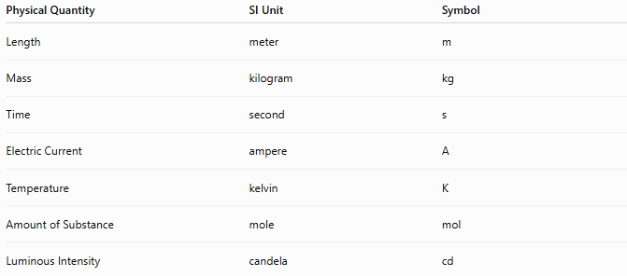
Physical Quantity | SI Unit | Symbol
Length | meter | m
Mass | kilogram | kg
Time | second | s
Electric Current | ampere | A
Temperature | kelvin | K
Amount of Substance | mole | mol
Luminous Intensity | candela | cd

2. Derived Quantities
# Source: AI Source: Provided by: [Data Path: Persons Table -> ID Column: 1, Name_En Column: Motasem Essam] -> From: [ChatGPT] on [7/17/2026]
Derived quantities are formed by combining two or more base quantities.
Examples:
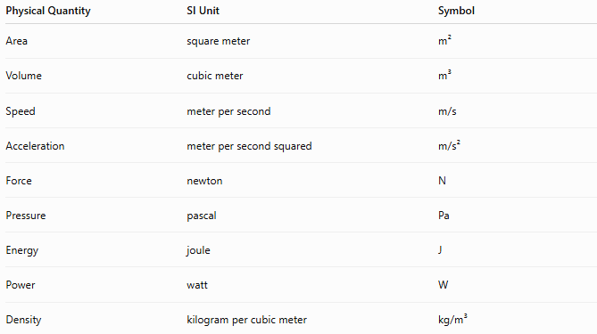
Physical Quantity | SI Unit | Symbol
Area | square meter | m²
Volume | cubic meter | m³
Speed | meter per second | m/s
Acceleration | meter per second squared | m/s²
Force | newton | N
Pressure | pascal | Pa
Energy | joule | J
Power | watt | W
Density | kilogram per cubic meter | kg/m³

Scalar and Vector Quantities
# Source: AI Source: Provided by: [Data Path: Persons Table -> ID Column: 1, Name_En Column: Motasem Essam] -> From: [ChatGPT] on [7/17/2026]
Physical quantities are also classified by whether they have direction.

Scalar Quantities
# Source: AI Source: Provided by: [Data Path: Persons Table -> ID Column: 1, Name_En Column: Motasem Essam] -> From: [ChatGPT] on [7/17/2026]
Scalars have magnitude only.
Examples:
- Length
- Mass
- Time
- Temperature
- Area
- Volume
- Energy

Vector Quantities
# Source: AI Source: Provided by: [Data Path: Persons Table -> ID Column: 1, Name_En Column: Motasem Essam] -> From: [ChatGPT] on [7/17/2026]
Vectors have both magnitude and direction.
Examples:
- Displacement
- Velocity
- Acceleration
- Force
- Momentum

Examples of Physical Quantities
# Source: AI Source: Provided by: [Data Path: Persons Table -> ID Column: 1, Name_En Column: Motasem Essam] -> From: [ChatGPT] on [7/17/2026]
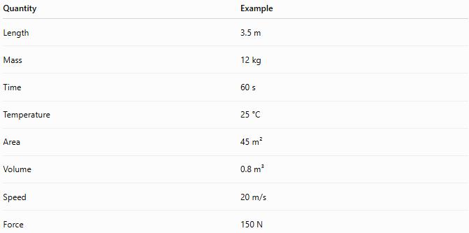
Quantity | Example
Length | 3.5 m
Mass | 12 kg
Time | 60 s
Temperature | 25 °C
Area | 45 m²
Volume | 0.8 m³
Speed | 20 m/s
Force | 150 N

Importance
# Source: AI Source: Provided by: [Data Path: Persons Table -> ID Column: 1, Name_En Column: Motasem Essam] -> From: [ChatGPT] on [7/17/2026]
Physical quantities:
- Form the foundation of physics.
- Describe the physical world quantitatively.
- Enable mathematical modeling.
- Support engineering analysis.
- Improve scientific communication.
- Ensure measurement consistency.

Applications
# Source: AI Source: Provided by: [Data Path: Persons Table -> ID Column: 1, Name_En Column: Motasem Essam] -> From: [ChatGPT] on [7/17/2026]
Physical quantities are used in:
- Physics
- Chemistry
- Engineering
- Manufacturing
- Medicine
- Astronomy
- Environmental science
- Construction
- Surveying
- Everyday measurements

Physical Quantity vs. Measurement Unit
# Source: AI Source: Provided by: [Data Path: Persons Table -> ID Column: 1, Name_En Column: Motasem Essam] -> From: [ChatGPT] on [7/17/2026]
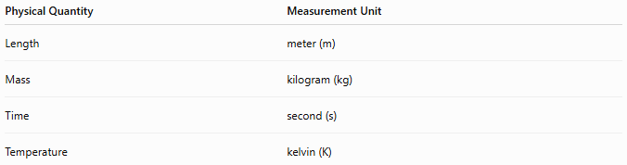
Physical Quantity | Measurement Unit
Length | meter (m)
Mass | kilogram (kg)
Time | second (s)
Temperature | kelvin (K)
A physical quantity is what is being measured, while a measurement unit is the standard used to express that measurement.

Physical Quantity vs. Physical Property
# Source: AI Source: Provided by: [Data Path: Persons Table -> ID Column: 1, Name_En Column: Motasem Essam] -> From: [ChatGPT] on [7/17/2026]
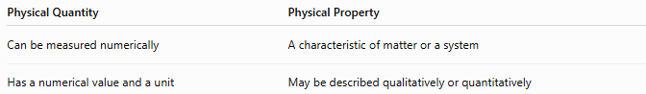
Physical Quantity | Physical Property
Can be measured numerically | A characteristic of matter or a system
Has a numerical value and a unit | May be described qualitatively or quantitatively
Example:
- Density is both a physical property and a measurable physical quantity.
- Color is a physical property but is not usually expressed as a numerical physical quantity.

Common Mistakes
# Source: AI Source: Provided by: [Data Path: Persons Table -> ID Column: 1, Name_En Column: Motasem Essam] -> From: [ChatGPT] on [7/17/2026]
- Confusing physical quantities with measurement units.
- Omitting units when reporting values.
- Confusing scalar quantities with vector quantities.
- Assuming every physical property is a measurable physical quantity.
- Mixing incompatible units without conversion.

Key Points
# Source: AI Source: Provided by: [Data Path: Persons Table -> ID Column: 1, Name_En Column: Motasem Essam] -> From: [ChatGPT] on [7/17/2026]
- A physical quantity is a measurable property.
- Every physical quantity has:
  - A magnitude
  - A measurement unit
- Physical quantities are classified as:
  - Fundamental (Base) Quantities
  - Derived Quantities
- They may also be:
  - Scalar
  - Vector
- Physical quantities are the basis of scientific measurement and engineering calculations.

Conclusion
# Source: AI Source: Provided by: [Data Path: Persons Table -> ID Column: 1, Name_En Column: Motasem Essam] -> From: [ChatGPT] on [7/17/2026]
Physical Quantities are measurable properties of objects, materials, or physical phenomena that can be expressed using a numerical value and a unit of measurement. They provide the foundation for describing, analyzing, and comparing the physical world in a consistent and quantitative manner. Physical quantities are classified as fundamental or derived, and as scalar or vector, depending on their characteristics. By combining a magnitude with a standardized measurement unit, physical quantities enable accurate scientific observation, engineering design, and universal communication across all fields of science and technology.

